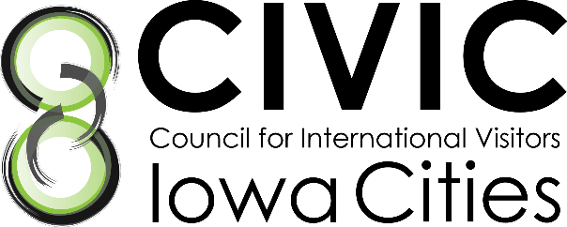

Job Description: Communications Coordinator

Position Description: The Communications Coordinator is a critical support position that furthers the mission of CIVIC through effective use of communication channels to increase the public’s awareness of (1) CIVIC’s mission, vision, and values, (2) its ongoing programming, (3) funding needs, and (4) the value of hosting international visitors in promoting international peace and prosperity. This is a paid position that can be conducted virtually.
Expectations: This position requires a 12-month commitment, averaging 10 hours per week. The coordinator is expected to conduct him/her/themself in a professional manner and to abide by all CIVIC procedures and policies. The coordinator is responsible for the Primary Responsibilities as outlined below but is also expected to collaborate and cooperate in the development, implementation and maintenance of all CIVIC programs as needed.
Primary Responsibilities:
- Serve as liaison to the Communications Committee (composed of board members and volunteers)
  - Help develop, implement, and maintain communications projects and procedures as developed by the Committee
- Maintain and enhance web and social media communications platforms
  - Utilize analytics to understand platform usage and trends
  - Develop and implement strategies to grow social media presence
  - Develop social media “action plans” for International Visitors Leadership Program and other visits
  - Review website and propose improvements to Communications Committee
- Manage Constant Contact emailing list in cooperation with Membership/Fundraising Team
- Send Constant Contact communications as required for programming
- Produce [quarterly] newsletter based on content input from Executive Director (ED) and the Board
- Design Annual Report based on content input from the Board and ED
- Document CIVIC programs (images, stories, and videos) in cooperation with the Membership Team
- Assist with planning the annual Celebration of Citizen Diplomacy Dinner
- Assist with other programming as needed
- Assist with visitors as needed
- Attend CIVIC-sponsored events such as the Annual Membership Meeting and the Celebration of Citizen Diplomacy Dinner
Required Qualifications:
- Current undergraduate student in good standing or recent graduate
- Excellent written and verbal communication skills
- Demonstrated proficiency in management of web and social media platforms, including Facebook, Twitter, and YouTube
- Strong organizational and time management skills
- Ability to work independently and as a member of a busy team
- Interest in global cultures
Desired Qualifications:
- Major in Communication Studies, Journalism & Mass Communication, Marketing, or other related area
- Work experience (6 months or more) in similar role
- Knowledge of graphic design (Canva)
- Demonstrated interest in non-profit organizations
- Knowledge of website platform, WIX

